**MD ZIAUDDIN**

**2403A51271**

AI ASSISTED CODING

**ASSIGNMENT-2.5**

# API Configuration:

* + Register for a free OpenWeatherMap API key.
  + Read the documentation and test API calls using tools like Postman or Python

requests.

# NLP Integration:

* + Use spaCy or NLTK to extract city names from user input.
  + Convert natural language queries to appropriate API parameters.

# Chatbot Design:

* + Develop a basic chatbot using Python with user input and response cycles.
  + Integrate it with OpenWeatherMap API to display temperature, condition, and humidity.

# Prompt:

Build a Python chatbot that:

1. Accepts natural language queries like "What’s the weather in Mumbai?" or "Is it raining in New York?".
2. Extracts the city name from the query (use spaCy or regex).
3. Calls the OpenWeatherMap API using my API key.
4. Displays weather details: condition, temperature (in Celsius), and humidity.
5. Runs in a loop until the user types 'exit'.
6. Handle API errors (like wrong city name).

**Code:**

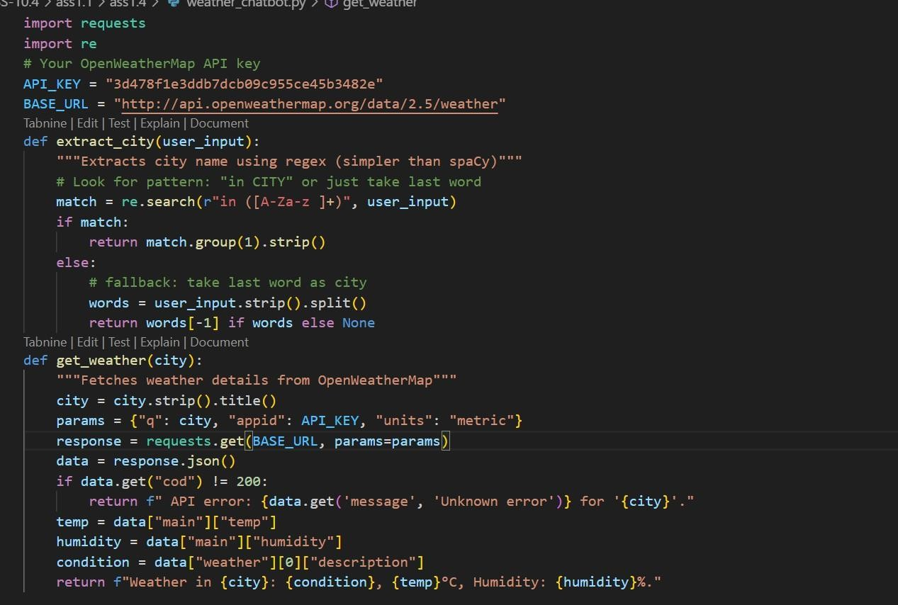

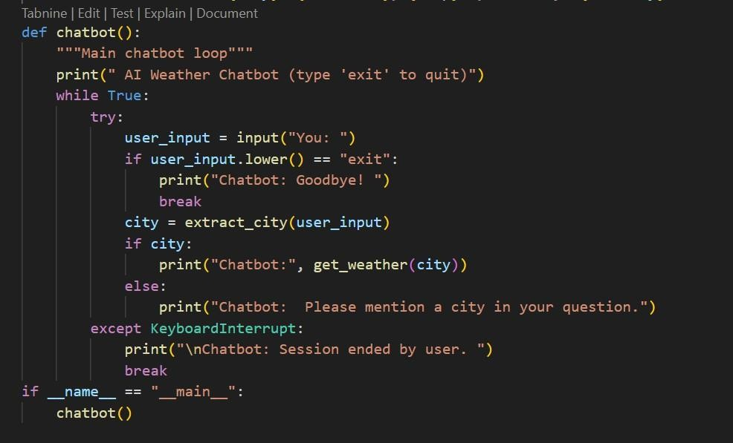

**Output:**

